|  |  |  |
| --- | --- | --- |
| **Name: Adithya M** | **SRN: PES1UG20CS621** | **Section: K** |
| **Date: 13/1/2022** | **Lab No: 1** |

**Use Case Diagram**

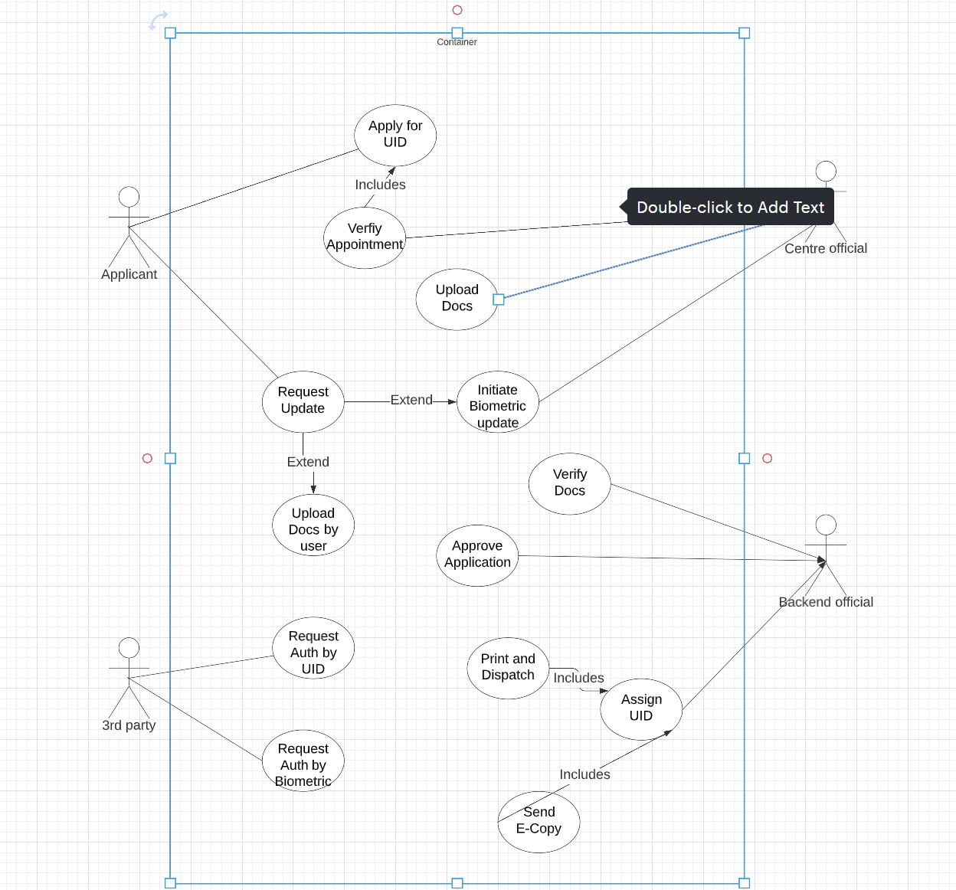

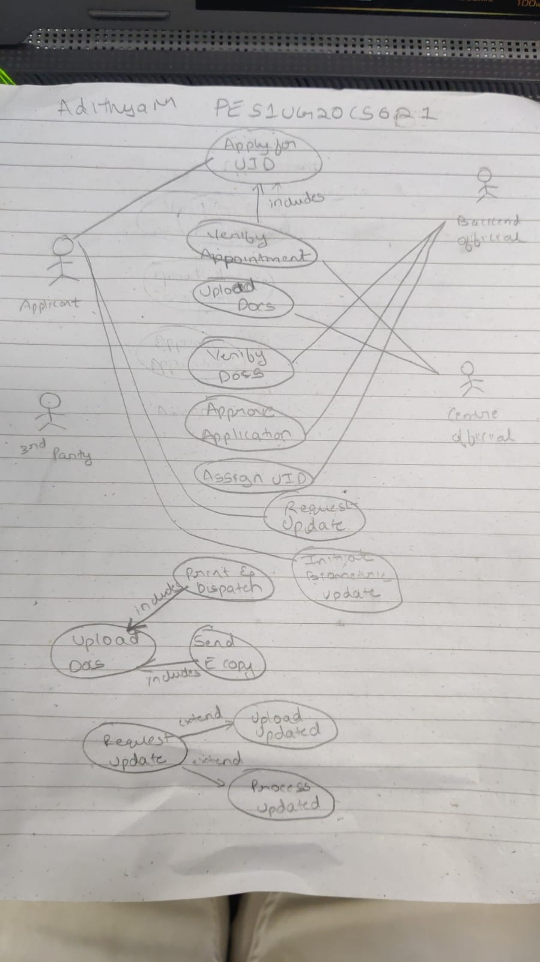

**Use Case Description:**

|  |  |
| --- | --- |
| **1** | **Title or Reference Name: "Verify Appointment"**  **Purpose: To confirm that the applicant has all the necessary documents and biometrics and has scheduled an appointment at the local UIDN Centre.**  **Actors: UIDN Centre Official**  **Pre-Conditions: The applicant must have scheduled an appointment and provided all necessary documents and biometrics.**  **Post Conditions: The appointment is verified and approved, and the applicant's documents and biometrics are uploaded to the system.** |
| **2** | **Title or Reference Name: "Upload Documents and Biometrics"**  **Purpose: To scan and upload the applicant's documents and biometrics to the system.**  **Actors: UIDN Centre Official**  **Pre-Conditions: The applicant must have provided all necessary documents and biometrics.**  **Post Conditions: The applicant's documents and biometrics are scanned and uploaded to the system and the UID card is printed and dispatched.** |
| **3** | **Title or Reference Name: "Approve Application"**  **Purpose: To review the applicant's information, check for errors or inconsistencies, and approve the application.**  **Actors: Backend Officials**  **Pre-Conditions: The applicant's documents and biometrics must have been verified and uploaded to the system.**  **Post Conditions: The application is approved, and a unique identification number is assigned to the applicant.** |
| **4** | **Title or Reference Name: "Apply for UID Number"**  **Purpose: To simplify the process of applying for a UID Number and ensure that all necessary information and documents are provided.**  **Actors: Applicant**  **Pre-Conditions: The applicant must have all the necessary documents and biometrics to apply for the UID number.**  **Post Conditions: A unique identification number is assigned to the applicant, and the applicant's information is stored in the system.** |
| **5** | **Title or Reference Name: "Request Update of Details"**  **Purpose: To allow the applicant to update their details in the system after receiving the UID card.**  **Actors: Applicant**  **Pre-Conditions: The applicant must have received the UID card and have updated details that need to be made.**  **Post Conditions: The applicant's details are updated and a new UID card with updated details is issued.** |